Web Development (WEDE5020)
Mukendi Ruan Kasongo
ST10537490
Contents
Website Project Proposal 1: National Zoological Garden 1

Website Project Proposal 1: National Zoological Garden
- Organisation Overview
Organisation Name: National Zoological Garden of South Africa (Pretoria Zoo)
The National Zoological Garden (NZG), commonly known as Pretoria Zoo, was founded in 1899 and became the official National Zoological Gardens in 1916. It is associated with the South African National Biodiversity Institute (SANBI). The organisation focuses on conservation, research, environmental education and visitor experiences.
Mission: To support biodiversity conservation through animal care, research, education and public awareness.
Vision: To contribute to biodiversity conservation while providing valuable educational and visitor experiences.
Target audience: Families, School groups, Tourists, Students, Researchers, Conservation enthusiasts and general visitors.
- Website Goals and Objectives
The proposed website will provide a modern and user-friendly platform for planning visits. The main objectives are to:
- Increase online ticket purchases.
- Provide accurate visitor information.
- Promote conservation and educational programmes.
- Advertise events and activities.
- Improve communication with visitors.
- Increase awareness of conservation initiatives.
Key Performance Indicators (KPIs):
- Increase online ticket purchases by 20% within six months.
- Reduce the website bounce rate.
- Increase time spent on educational and conservation pages.
- Increase event and programme enquiries.
- Increase newsletter subscriptions.
- Current Website Analysis
The current website provides information about tickets, events, conservation, history, education and contact details. However, it could be improved with a more engaging homepage, simpler navigation and clearer information about tickets, opening times and directions. A mobile-first design would also improve accessibility.
- Proposed Website Features and Functionality
The website will include:
- Home: Hero image, events and quick links.
- About Us: History, mission, vision and conservation role.
- Animals: Searchable animal information.
- Visit Us: Opening times, prices, directions and accessibility.
- Tickets: Online ticket-purchase option.
- Education: School programmes and educational resources.
- Conservation: Current projects and initiatives.
- Events: Upcoming events and activities.
- Contact: Contact form, telephone, email and location.
- Design and User Experience
Color Scheme: Forest green, dark green, white and natural earth tones.
Typography: Aptos or another clean sans-serif font for readability.
Layout: Responsive and image-focused, with a large hero section and cards for tickets, animals, events and conservation. Important buttons such as “Buy Tickets” and “Plan Your Visit” will be clearly displayed.
- Technical Requirements
The website will use HTML, CSS, JavaScript. Bootstrap may be used for responsive design. Hosting will require a web server, domain name and SSL certificate.
- Timeline and Milestones
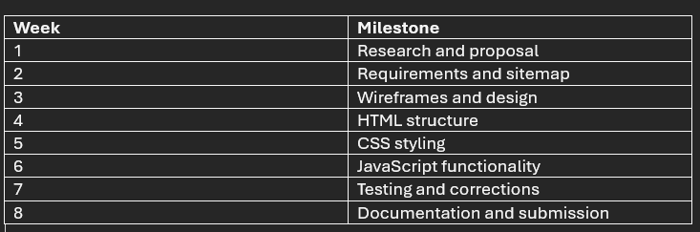
- Budget
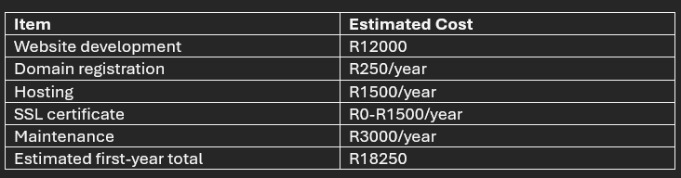
- References
National Zoological Garden. (2026). National Zoological Garden, Pretoria. Available at: https://www.pretoriazoo.org/
National Zoological Garden. (2026). Our History. Available at: https://www.pretoriazoo.org/about/our-history/
National Zoological Garden. (2026). Visit the Zoo. Available at: https://www.pretoriazoo.org/visit-the-zoo/
National Zoological Garden. (2026). Initiatives. Available at: https://www.pretoriazoo.org/initiatives/

Website Project Proposal 2: SPAR South Africa
- Organization Overview
Organisation Name: The SPAR Group Ltd – South Africa
SPAR South Africa is part of The SPAR Group Limited and operates a network of retail stores serving communities across South Africa. SPAR was launched in South Africa in 1963 and has developed into a major retail and community-focused brand.
Vision: To be the first-choice brand in the communities it serves.
Purpose: To support retailers in operating sustainable, profitable and professional businesses.
The target audience includes families, individual consumers, local communities, shoppers looking for specials, health-conscious customers and independent SPAR retailers.
- Website Goals and Objectives
The proposed website will provide customers with a convenient platform for finding products, specials, stores and useful information. The main objectives are to:
- Increase customer engagement.
- Make store information easier to find.
- Promote specials and promotions.
- Provide food, health and lifestyle information.
- Help customers locate their nearest SPAR store.
- Encourage online interaction with the brand.
Key Performance Indicators (KPIs):
- Increase monthly website visitors by 20%.
- Increase clicks on store-locator pages.
- Increase engagement with specials and promotions.
- Increase newsletter subscriptions.
- Increase customer enquiries and feedback.
- Current Website Analysis
The existing SPAR online presence provides useful information such as nutritional information, recipes and lifestyle content. However, the website could be improved by making store finding, specials, products and contact information more visible. Simplified navigation, stronger visual organisation and responsive design would help customers find information faster on desktop, tablet and mobile devices.
- Proposed Website Features and Functionality
The redesigned website will contain:
- Home: Promotions, specials and announcements.
- Find a Store: Search by city, suburb or location.
- Specials: Current promotions and weekly deals.
- Products: Product categories and featured products.
- Recipes: Recipes and meal ideas.
- Healthy Living: Nutrition and lifestyle information.
- About SPAR: History, purpose and values.
- Community: Social responsibility initiatives.
- Contact Us: Enquiry and feedback form.
An interactive store locator will allow users to find nearby stores and view information such as opening hours and services.
- Design and User Experience
Colour Scheme: SPAR's red, white and green branding will be used consistently.
Typography: A modern sans-serif font will provide readable body text and clear headings.
Layout: A clean grid-based design will use product and promotion cards. The homepage will prioritise frequently used features such as “View Specials” and “Find a Store.”
The website will use responsive design, accessible colour contrast and simple navigation, with particular attention given to mobile users.
- Technical Requirements
The website will use HTML5, CSS3 and JavaScript, with Bootstrap used where appropriate. A database could store information, products and promotions. Reliable hosting, an SSL certificate and a suitable domain will also be required.
- Timeline and Milestones
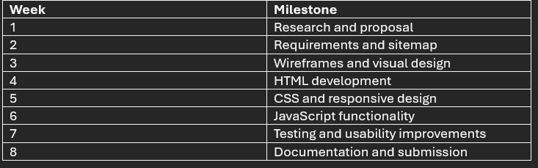
- Budget
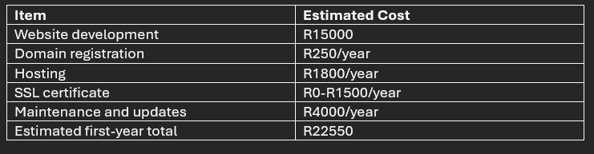
- References
SPAR Group. (2013). Historical Timeline. Available at: https://www.spar.co.za/
SPAR Group. (2013). Vision, Purpose and Values. Available at: https://www.spar.co.za/
SPAR. (2026). SPAR Inspiration: Healthy Eating. Available at: https://www.spar.co.za/inspiration/My-Family/My-Familys-Health/Nutrition/Healthy-eating
SPAR. (2026). SPAR Inspiration: Budgeting Brilliance. Available at: https://www.spar.co.za/inspiration/Stretch-My-Rands/Budgeting-Brilliance/Basics-of-Savings-and-Investments

